1. After configuring Kubernetes master and worker nodes on running command kubectl get nodes in the master node

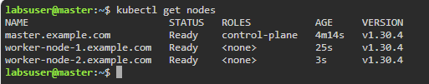

1. In Worker node 1 installed NFS and getting status

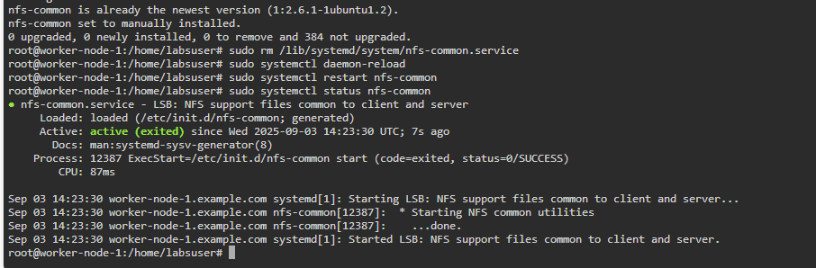

1. Adding the mysql.yaml, mysql-config.yaml, mysql-secret.yaml and
2. kubectl apply -f mysql-secret.yaml

kubectl apply -f mysql.yaml

kubectl apply -f mysql-config.yaml

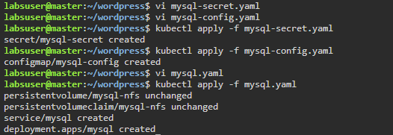

1. Getting the PV, PVC, services and deployments

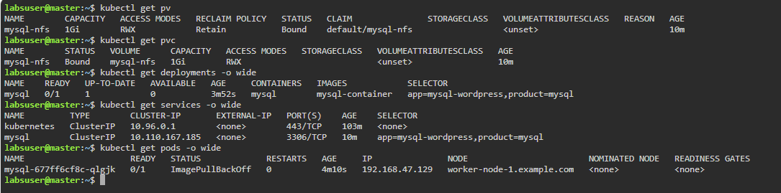

1. Adding wordpress.yaml 

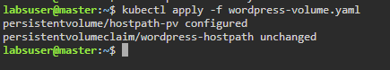

1. While getting persistent volume and claim,

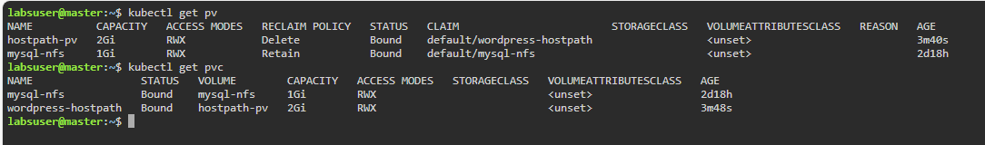

1. Add wordpress-deployment.yaml , created wordpress service and deployment

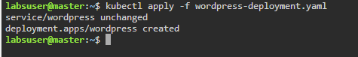

1. On getting list of pods, getting both mysql and wordpress



1. Getting the list of services, Node port is 32401

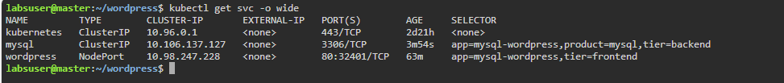

1. On navigating into curl localhost:32401, able to see the wordpress page

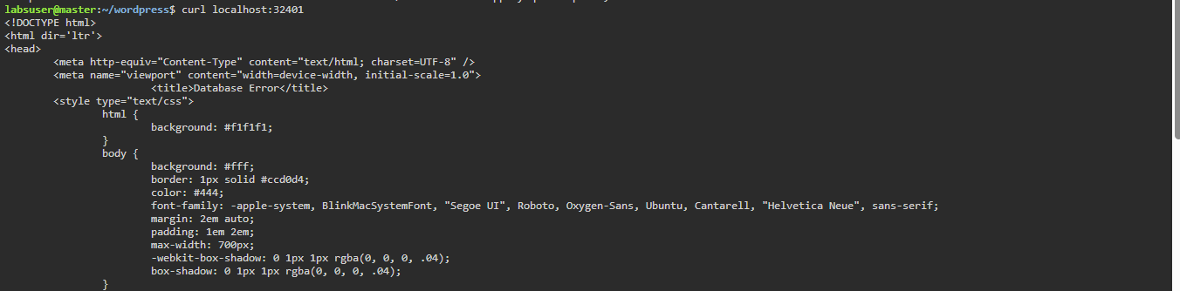

1. Not able to view Desktop as its taking time to load.